July Wellman

CS 470: Full Stack Development II

Southern New Hampshire University

September 7, 2025

**Installation, MongoDB Image, and Testing**

*Docker Desktop running the MongoDB image*

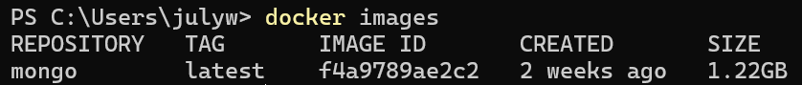

*Docker image from Power Shell*

*Power Shell setup to pull Mongo image*